**SETTING UP APPLICATION**

**ENVIRONMENT**

**TEAM DETIALS:**

TEAM NUMBER : PNT2022TMID292270

COLLEGE NAME : UNIVERSITY COLLEGE OF ENGINEERING

DEPARTMENT : COMPUTER SCIENCE AND ENGINEERING.

**TEAM MEMBERS:**

GIRUPANETHI K

YOGESH K

RAJA K

AAKASH N

**EVNIRONMENTAL SETUP**

* CREATE FLASK PROJECT
* CREATE IBM CLOUD ACCOUT
* INSTALL IBM CLOUD CLI
* DOCKER CLI INSTALLATION
* CREATE AN ACCOUNT IN SENDGRID

# FLASK SETUP

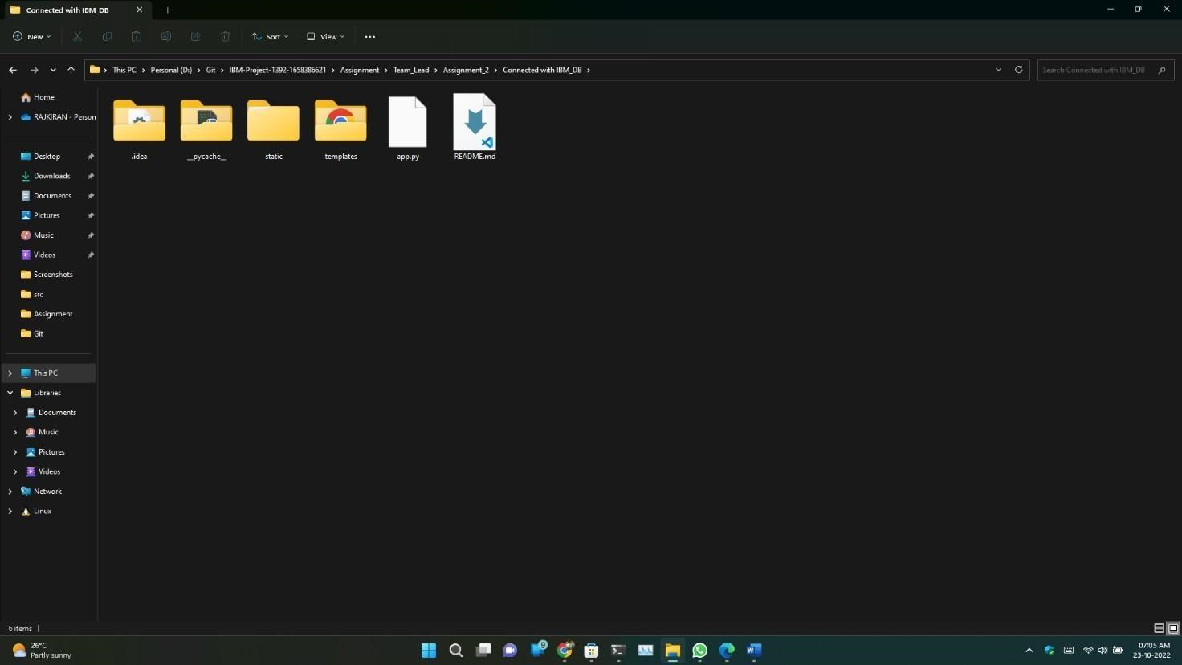

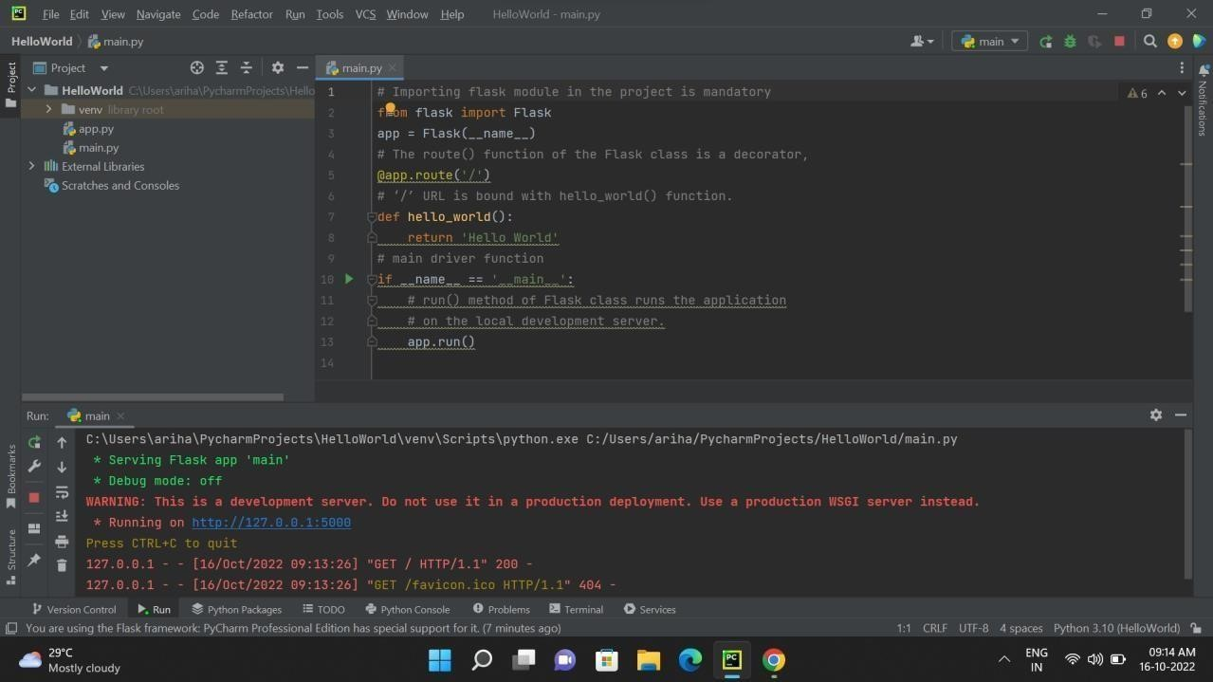

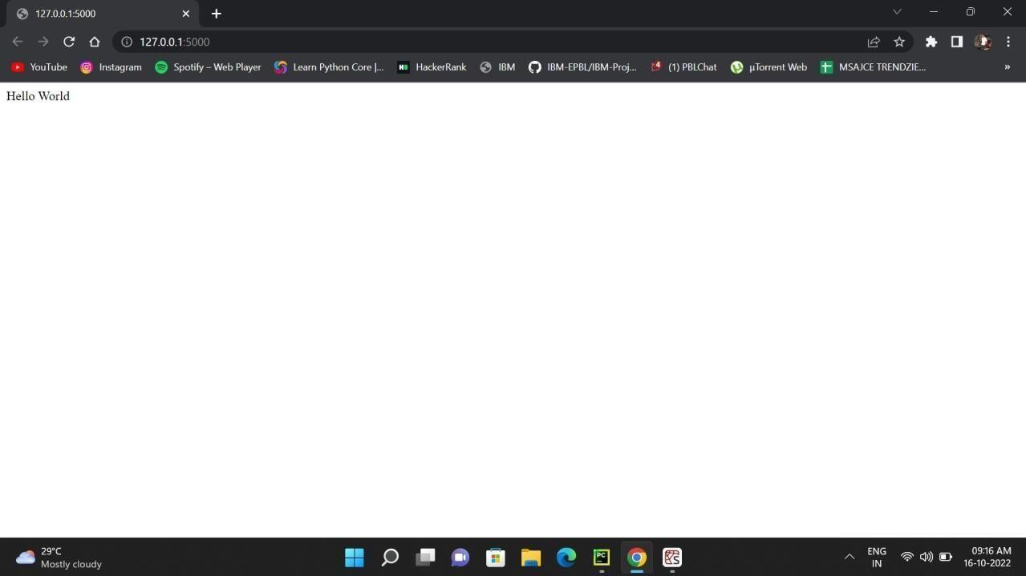

**DOCKER SETUP**



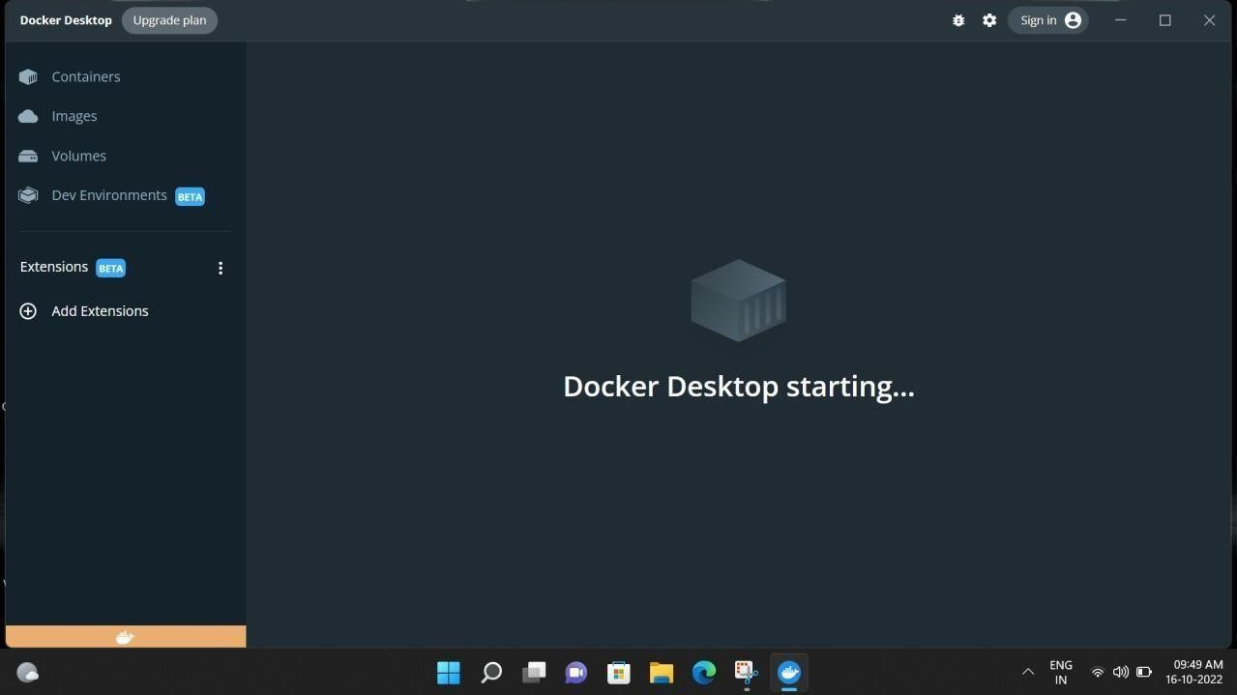

# COLUD ACCOUNT CREATION

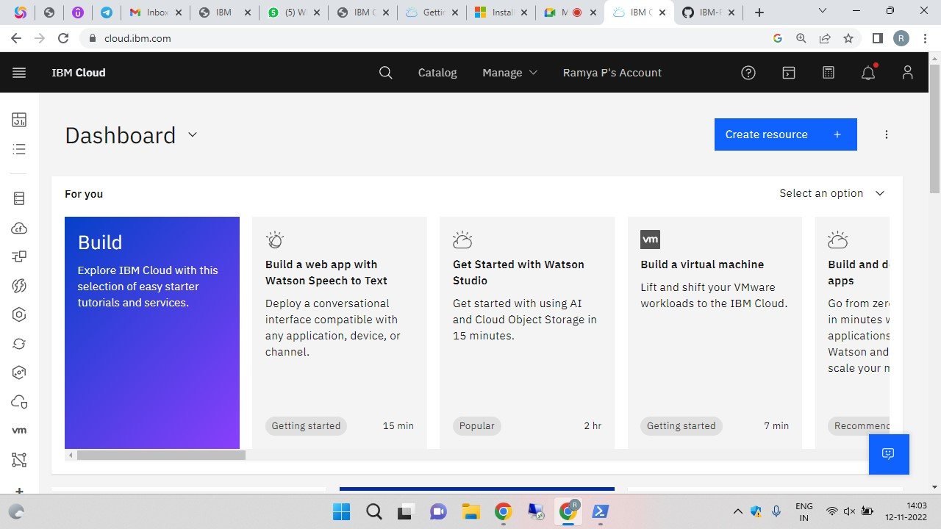

# SENDGRID ACCOUNT CREATION

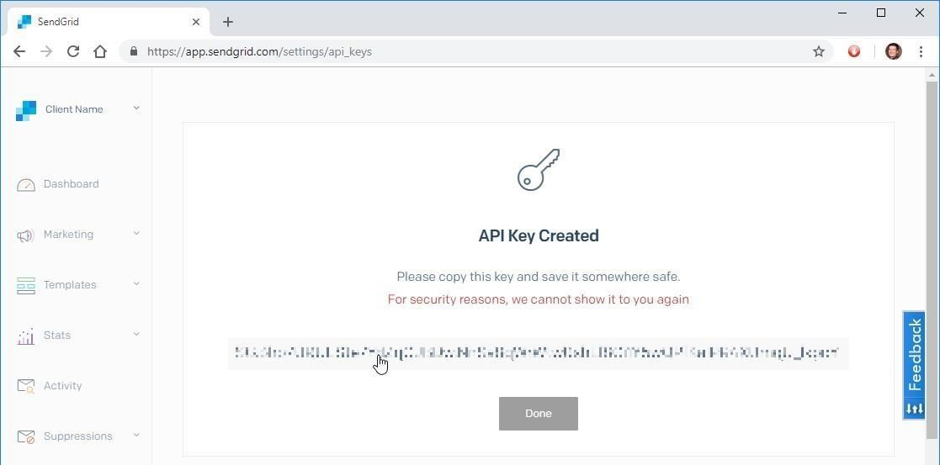

# IBM CLOUD CLI INSTALL

